Event Planner
Abstract
This report outlines the development and implementation of an Event Planning Project, a role-based event management web application. The application is designed to facilitate effective event planning and coordination among three distinct roles: Manager, User, and Worker. Leveraging the capabilities of Python, Flask, HTML, CSS, JavaScript, and JSON for data storage, the application aims to streamline event management processes, enhance collaboration, and improve task tracking.

Introduction
Event management is a complex task that requires coordination among various stakeholders. Traditional methods often lead to inefficiencies and miscommunication. The Event Planning Project aims to address these challenges by providing a web-based platform that allows different roles to collaborate effectively. This project not only simplifies the event management process but also enhances the user experience through a well-structured interface.

Problem Statement
Existing event management systems often fail to provide a tailored experience for different user roles, leading to confusion and inefficiencies. Furthermore, manual processes for task assignment, approval workflows, and event tracking can cause delays and mismanagement. This project seeks to create a solution that integrates role-specific functionalities to streamline these processes.

Objectives
- To develop a web application with distinct functionalities for Managers, Users, and Workers.
- To implement a worker approval workflow to ensure task assignments are managed effectively.
- To allow Managers to create events with associated tasks and assign roles accordingly.
- To enable Users to track their assigned events and update task progress.
- To provide a user-friendly interface with theme support and real-time updates on event status.

Existing System
Current event management solutions lack the flexibility to accommodate various user roles effectively. They often provide a one-size-fits-all approach, which can lead to overload for some users while leaving others with inadequate functionality. Additionally, existing systems may not support real-time updates or task tracking, making it challenging to adapt to dynamic event requirements.
Proposed System
The proposed Event Planning Project introduces a web application where users can log in based on their roles (Manager, User, Worker) and access functionalities tailored to their needs. The system includes features such as multi-role login, event creation and task assignment, approval workflows for Workers, and dashboards for each user type to monitor their responsibilities.
Technology Stack
- Backend: Python, Flask
- Frontend: HTML, CSS, JavaScript
- Data Storage: JSON

Project folder structure
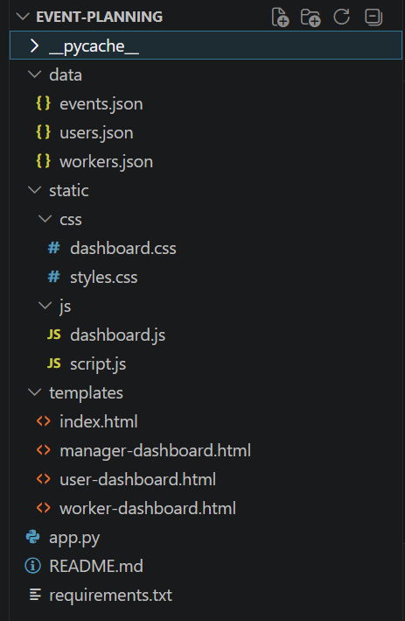

User Flow Diagram
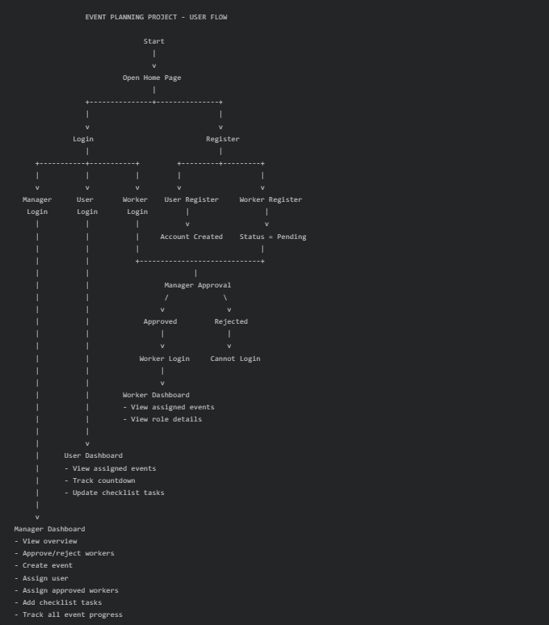

User Case diagram

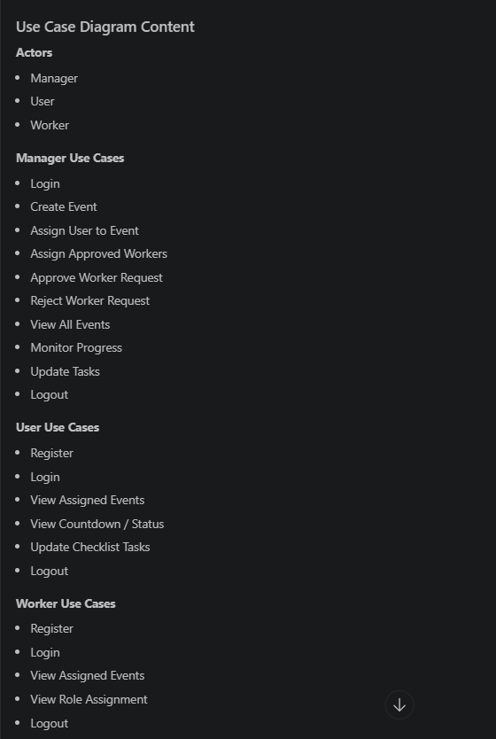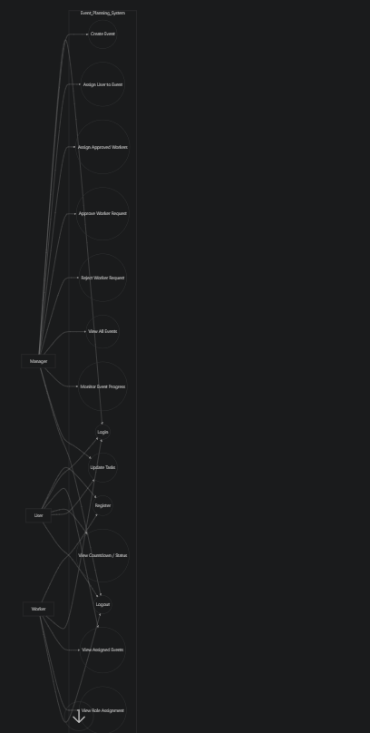

Overall Function Flow
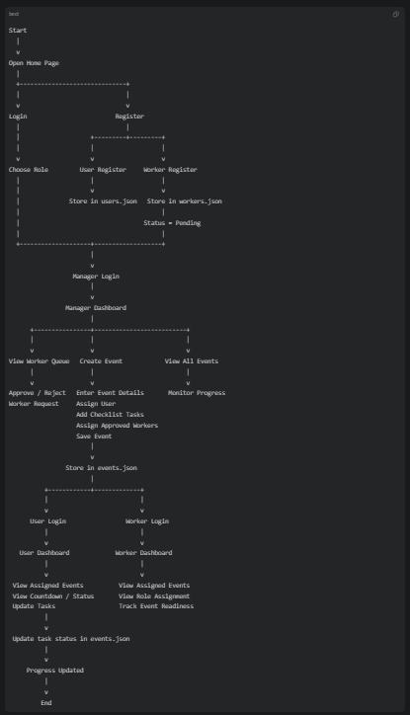

Project Setup:
1. Requirements
To run the Event Planning Project, the following software is required:
- Python 3.x
- Flask
- Web browser
- Code editor such as VS Code
2. Project Folder Structure
The project contains the following main files and folders:
- app.py – Flask backend server and API routes
- templates/ – HTML templates for login and dashboards
- static/css/ – CSS files for styling
- static/js/ – JavaScript files for frontend logic
- data/users.json – stores manager and user data
- data/workers.json – stores worker data and approval status
- data/events.json – stores event details, tasks, and assignments
3. Install Dependencies
Open terminal in the project folder and run:
python -m pip install -r requirements.txt
4. Run the Project
Start the Flask server using:
python app.py
5. Open in Browser
After the server starts, open:
http://localhost:3000
6. Default Login Credentials
Manager
- Email: manager@event.com
- Password: Manager@123
- Manager Code: MGR-2026
User
- Email: user@event.com
- Password: User@123
- Event ID: EVT-101
7. Registration Setup
- New users can register from the Register tab
- Workers can register by selecting a role
- Workers remain in pending status until approved by the manager
8. Data Storage Setup
The project does not use a database.
All records are stored in JSON files:
- users.json
- workers.json
- events.json
9. System Initialization
When app.py runs:
- the data folder is checked
- required JSON files are created if missing
- the Flask application starts on port 3000
10. Notes
- Restart the server after backend changes
- Use hard refresh in browser if old UI is still loading
- Since storage is JSON-based, data is easy to inspect and edit manuall

System Modules
- User Authentication Module
- Event Management Module
- Task Assignment Module
- Approval Workflow Module
- Dashboard Module
Working Process / Workflow
The application follows a structured workflow:
- Users register based on their roles.
- Managers create events and assign tasks to Workers.
- Workers await approval from Managers.
- Once approved, Workers can log in to view assigned tasks.
- Users track event progress and update task statuses.

Data Storage Design
JSON files are used to store user credentials, event details, and task assignments. Each role has a defined structure:
- Managers: Store event data and user assignments.
- Users: Store event participation and task progress.
- Workers: Store registration details and approval status.

Features
- Multi-role login and registration
- Worker approval workflow
- Event creation with associated tasks
- Separate dashboards for Managers, Users, and Workers
- Countdown and event status tracking
Advantages
- Improved collaboration among different roles.
- Real-time updates enhance responsiveness to changes.
- User-friendly interface promotes ease of use.
- Efficient task tracking leads to better resource management.

Limitations
- Dependency on JSON for data storage may limit scalability.
- Real-time features are limited by the underlying technology.

Future Enhancements
- Integration of a database for better data management.
- Implementation of notification systems to alert users of updates.
- Enhancement of the user interface based on user feedback.
- Incorporation of advanced analytics for event performance tracking.

Conclusion
The Event Planning Project provides a comprehensive solution for managing events through a role-based web application. By addressing the specific needs of Managers, Users, and Workers, the application enhances collaboration, task management, and event tracking. The implementation of this system can significantly improve the efficiency of event planning processes.

